
C PROGRAMMING ASSIGNMENT
Student Submission Template

Student Name | R ROHITHKUMAR
Register Number | 1911260135
Course Code & Name | CSA-0211/_C-Programming
Slot | Slot D
Assignment / Task Title | 2
GitHub Repository URL | https://github.com/Rohith45-ultra/CSA0211-1911260135-Cprogramming.git
Submission Date | 5/11/2026
Instructions to Students
- Complete every section for each assigned task.
- Write your own explanation, algorithm/pseudocode, and program.
- Run the program and insert a clear screenshot of the output.
- Include test cases and a short analysis where applicable.
- If code is maintained on GitHub, provide the correct repository link

TASK 1 — Precedence, Associativity and the Discount Bug (6 Marks)
Bloom's Level: K4 – Analyse

Task / Problem Statement
The pharmacy billing expression calculates a bill with a senior-citizen discount, GST and an additional Rs 50 reduction when the amount is above Rs 1000. The original expression has precedence and integer-division problems. The statement count = count++ + 1 also modifies count more than once without a defined sequence point.

Aim
To analyse C operator precedence and associativity, identify incorrect calculations, and rewrite the billing logic in a clear and correct form.

Concept / Theory
Multiplication and division have higher precedence than addition and subtraction and are evaluated left to right. Relational operators are evaluated after arithmetic. The conditional operator ?: has lower precedence than relational operators. Integer division discards the fractional part. The postfix increment produces the old value and also modifies the variable.

Procedure / Algorithm
  - Read price, quantity and senior-citizen status.
  - Calculate gross amount as price multiplied by quantity.
  - If eligible, calculate 15% discount; otherwise use zero.
  - Calculate GST on the discounted amount, then add it to the discounted amount.
  - If the resulting amount is above Rs 1000, subtract Rs 50 and display the bill.

Program / Source Code
#include <stdio.h> int main(void)
{
double price, gross, discount, taxable, gst, total, net; int qty, senior;

printf("Enter price and quantity: ");
if (scanf("%lf %d", &price, &qty) != 2 || price < 0 || qty < 0) return 1;

printf("Senior citizen? (1=yes, 0=no): ");
if (scanf("%d", &senior) != 1 || (senior != 0 && senior != 1)) return 1;

gross = price * qty;
discount = senior ? gross * 15.0 / 100.0 : 0.0; taxable = gross - discount; gst = taxable * 5.0
/ 100.0; total = taxable + gst; net = total
> 1000.0 ? total - 50.0 : total;

printf("Gross amount: Rs %.2f\n", gross); printf("Discount: Rs %.2f\n", discount); printf("GST: Rs %.2f\n", gst); printf("Total: Rs %.2f\n", total); printf("Net payable: Rs %.2f\n", net); return 0; }

Output:
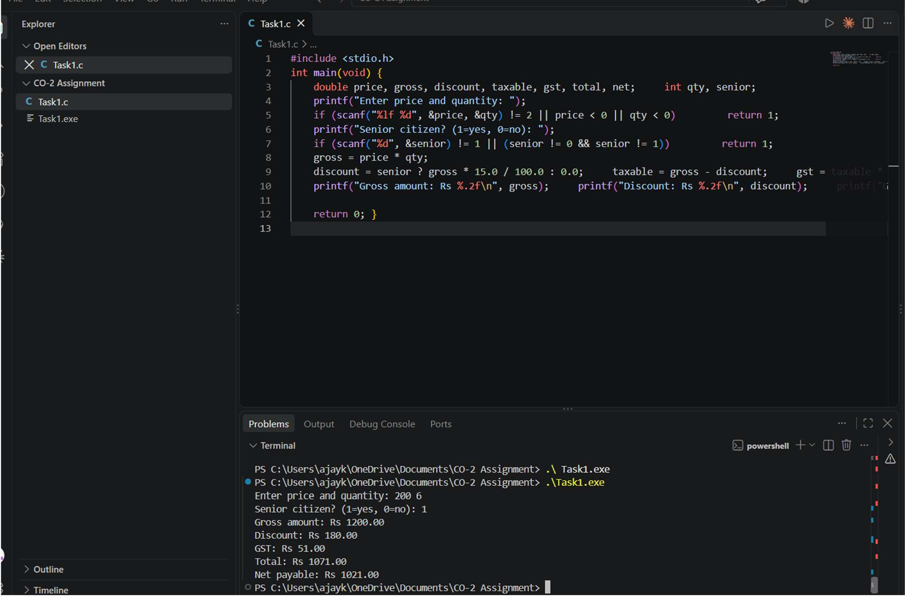

Analysis / Discussion
For example, use three bills: (Rs 100, quantity 2, senior), (Rs 250, quantity 5, non-senior), and (Rs 500, quantity 3, senior). Correct calculations are: bill 1 gross Rs 200, discount Rs 30, GST Rs 8.50, total Rs 178.50, net Rs 178.50; bill 2
gross Rs 1250, discount Rs 0, GST Rs 62.50, total Rs 1312.50, net Rs 1262.50; bill 3 gross Rs 1500, discount Rs 225, GST Rs 63.75, total Rs 1338.75, net Rs 1288.75. The given expression applies multiplication/division left to right; `15 / 100` would be zero if both operands are integers, so the discount can disappear. The expression also applies GST to the original gross amount rather than clearly applying it after the discount. The ternary expression applies the Rs 50 reduction only when total is greater than 1000. `count = count++ + 1` has undefined behaviour because count is modified by postfix
++ and again by assignment without a sequencing guarantee. `-Wall` may warn about an operation on `count` that may be undefined or unsequenced; exact diagnostic wording depends on compiler. Use `count += 1;` instead.

Alternative Concept and Complexity Analysis
Using intermediate variables gross, discount, taxable, GST and total adds a constant number of variables and arithmetic operations. Time complexity remains O(1), and extra space is O(1). The additional names make each stage easier to inspect and test. Brackets clarify the intended order, while intermediate variables make the calculation easier to maintain; using both is the clearest choice.

Result
The corrected program calculates the discount before GST and applies the conditional Rs 50 reduction. Intermediate variables avoid precedence mistakes and improve readability.

TASK 2 — When Does Short-Circuit Evaluation Matter? (4 Marks)
Bloom's Level: K4 – Analyse

Task / Problem Statement
A railway ticket program grants a concession when a passenger is a senior citizen and the ticket class is eligible, or when the passenger has a verified disability card. Verification is a slow function that contacts a server.

Aim
To demonstrate short-circuit evaluation, compare logical and bitwise operators on conditions, and count calls to a slow verification function.

Concept / Theory
In `A && B`, B is evaluated only when A is true. In `A || B`, B is evaluated only when A is false. The operators `&` and `|` evaluate both operands and are bitwise operators; using them with Boolean-like values does not provide short-circuit behaviour.

Procedure / Algorithm
- Create a verification function that increments a call counter.
- Test the concession condition with different operand orders.
- Run 1,000 sample passengers and record verification calls.
- Compare logical operators with nested if statements and bitwise operators.
- Consider whether verification has an audit side effect before choosing an order.

Program / Source Code
#include <stdio.h>

static int verify_card(int card_valid, int *calls) { ++*calls;
/* represents a slow server check */ return card_valid; }

int main(void) { int calls_a = 0, calls_b = 0, calls_nested = 0; int passengers = 1000;
int concessions_a = 0, concessions_b = 0, concessions_nested = 0;

for (int i = 0; i < passengers; ++i) { int senior = (i % 4 == 0); int
eligible = (i % 3 == 0); int card
= (i % 10 == 0);

concessions_a += ((senior && eligible) || verify_card(card, &calls_a));

concessions_b += (verify_card(card, &calls_b) || (senior && eligible));

if (senior && eligible)
++concessions_nested;
else if (verify_card(card, &calls_nested))
++concessions_nested; }

printf("Order A verification calls: %d\n", calls_a); printf("Order B verification calls: %d\n", calls_b); printf("Nested-if verification calls: %d\n", calls_nested); printf("Concessions: %d, %d, %d\n",
concessions_a, concessions_b, concessions_nested); return 0; }

Output:

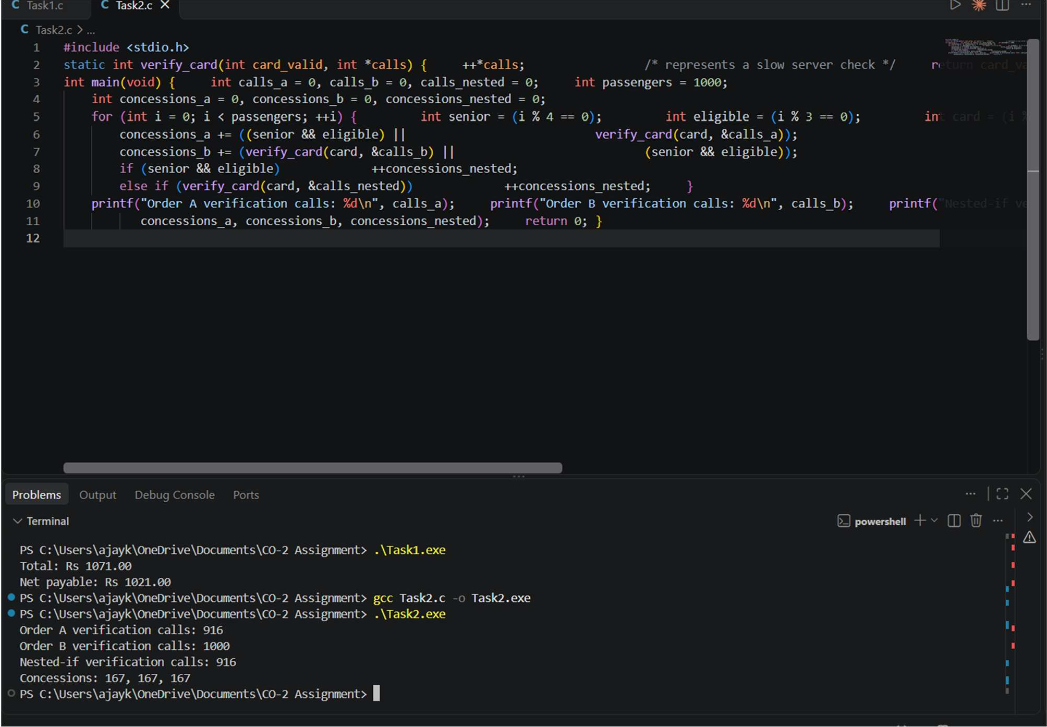

Analysis / Discussion
Order A evaluates the cheap senior-and-eligible condition first. The server call is skipped for passengers who already qualify. Order B checks the card first, so it makes a server call for every passenger. The nested-if version makes the call only when the first condition is false. For 1,000 passengers, Order A and nested-if make 1,000 minus the number who satisfy both senior and eligible; Order B makes 1,000 calls. The cheapest or most likely false condition should generally be placed first in an && chain; for an || chain, a cheap likely-true condition should be first. If verification records every passenger it checks in an audit log, changing the order changes the audit records. In that case, the side effect must be designed deliberately; do not reorder conditions only for speed. With `&` and `|`, both sides are evaluated, so the slow function is called even when the left side already determines the result.

Alternative Concept and Complexity Analysis
For n passengers, the logical short-circuit and nested-if approaches take O(n) overall, with the number of expensive calls depending on the data. The bitwise version also takes O(n), but evaluates both operands and may perform more server checks. Nested if statements express the same conditional behaviour clearly and are useful when actions must be controlled separately.

Result
Short-circuit operators reduce unnecessary verification calls when conditions are ordered carefully. Side effects such as audit logging must be considered before changing the order.

TASK 3 — Engineer a Device-Status Register with Bitwise Operators (6 Marks)
Bloom's Level: K4 – Analyse

Task / Problem Statement
A smart-home controller stores the ON/OFF state of up to eight devices in one unsigned char. Each bit represents one device.

Aim
To use bitwise operators to switch devices on and off, toggle a device, test its state, print the register in binary, and count active devices.

Concept / Theory
A bit mask is formed using `1u << dev`. OR sets a bit, AND with the inverted mask clears a bit, XOR toggles a bit, and AND tests a bit. Parentheses are important because shift has higher precedence than bitwise AND. An unsigned type avoids signed right-shift concerns when bit 7 is set.

Procedure / Algorithm
- Set the device bit using OR with its mask.
- Clear a device bit using AND with the inverted mask.
- Toggle a device bit using XOR.
- Test a bit using AND and print the register from bit 7 to bit 0.
- Count ON bits by checking each of the eight positions.

Program / Source Code
#include <stdio.h>

enum { LIGHT = 0, FAN = 1, AC = 2, HEATER = 3, PUMP = 4 };

unsigned char switch_on(unsigned char reg, int dev)
{ if (dev < 0 || dev > 7) return reg; return (unsigned char)(reg | (1u << dev)); } unsigned char switch_off(unsigned char reg, int dev) {
if (dev < 0 || dev > 7) return reg; return (unsigned char)(reg & ~(1u << dev)); }
unsigned char toggle(unsigned char reg, int dev)
{ if (dev < 0 || dev > 7) return reg; return (unsigned char)(reg ^ (1u << dev)); } int is_on(unsigned char reg, int dev) {
if (dev < 0 || dev > 7) return 0; return (reg & (1u << dev)) != 0; } void show(unsigned char reg)
{
for (int bit = 7; bit >= 0; --bit) putchar(((reg >> bit) & 1u) ? '1' : '0'); putchar('\n'); } int count_on(unsigned char reg)
{
int count = 0; for (int bit = 0; bit
< 8; ++bit) if (reg & (1u << bit))
++count; return count; } int main(void) { unsigned char reg = 0; reg = switch_on(reg, LIGHT); reg = switch_on(reg, AC); show(reg);
/* 00000101 */ reg = toggle(reg, FAN); reg = switch_off(reg, LIGHT); show(reg);
/* 00000110 */ printf("AC is %s, PUMP is
%s\n", is_on(reg, AC) ? "ON" :
"OFF", is_on(reg, PUMP) ? "ON" :
"OFF"); printf("Devices ON: %d\n", count_on(reg)); return 0; }

Output:

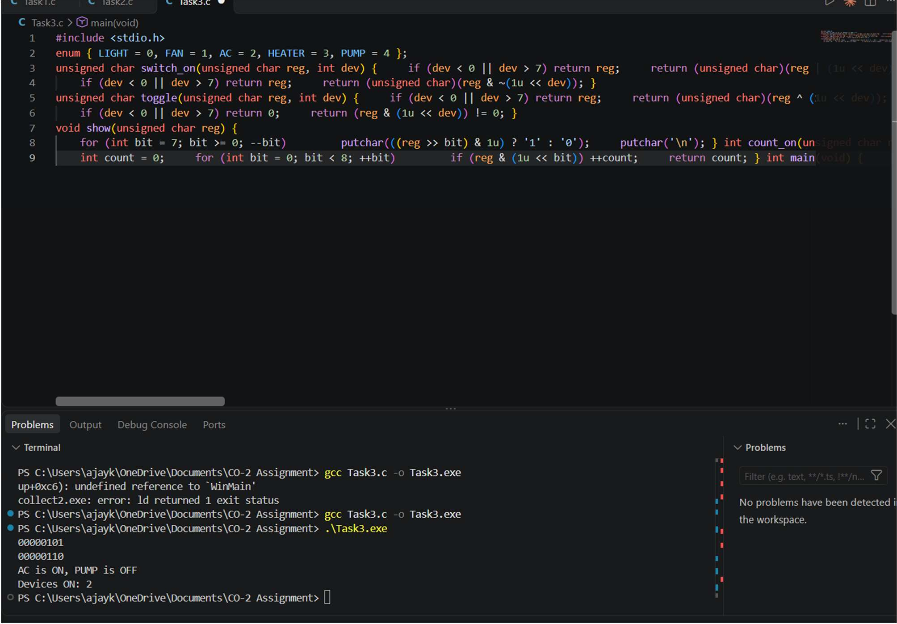

Analysis / Discussion
The register starts at 00000000. Turning LIGHT on gives 00000001 (1). Turning AC on gives 00000101 (5). Toggling FAN gives 00000111 (7). Turning LIGHT off gives 00000110 (6). Therefore AC is ON, PUMP is OFF, and two devices are ON. `reg & 1 << dev` is parsed as `reg & (1 << dev)` because shift has higher precedence than bitwise AND, but `(reg & 1) << dev` first isolates bit zero and then shifts it, so the results differ. With signed char, setting bit 7 may produce a negative value and right-shifting a negative signed value is implementation-defined. Use unsigned char and an unsigned mask. For eight devices, a byte uses 1 byte per home; an array of eight char values uses 8 bytes per home. For 1,000,000 homes, that is about 1 MB versus 8 MB, excluding other storage overhead. Both direct bit operations and array element access are O(1); counting ON devices is O(8), effectively constant for a fixed eight devices.

Result
The program stores all eight states in one byte and correctly performs set, clear, toggle, test, binary display and bit counting.

